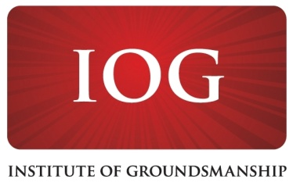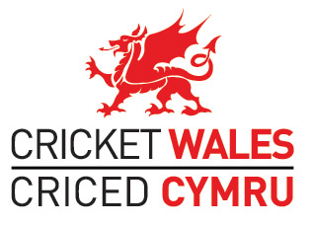

Initial Twelve-Month Contract for Consultancy Services to be provided to the Institute of Groundsmanship in Wales - £17000

The Institute of Groundsmanship in partnership with Cricket Wales, wishes to appoint a consultant initially for a twelve month period, to provide Community Asset Transfer support to targeted cricket clubs in Wales
Main Purpose of Consultancy Service
- To guide and support affiliated ECB/Cricket Wales clubs who are considering or undertaking Community Asset Transfer (CAT) of cricket facilities

- To advise Cricket Wales on strategic facility solutions within key Local Authorities with a particular focus on the preservation and development of cricket facilities during times of CAT

Specific Services

- To support Cricket Wales in identifying high risk Local Authority areas and priority clubs

- In conjunction with Cricket Wales, to influence Local Authorities in establishing realistic CAT timeframes (in partnership with other NGB’s as appropriate)

- To support priority clubs in following the ECB CAT guidance process, attending internal (club) and external (LA) meetings as appropriate. At times a ‘hands on role’ from the consultant is envisaged.

- To work in partnership with the WRU and the FAW Trust on cricket/rugby and cricket/football sites, liaising with the respective clubs, NGB’s and LA’s as appropriate

Contract Management

- Formal contract management will be through the Institute of Groundsmanship with weekly liaison also being with the Cricket Wales CEO

Duration of Contract

- An initial 12 month Contract for Services to commence in July 2017 and to be reviewed with potential extension in mind, subject to funding availability.

Financial Value of Contract

- A 12-month budget of £17000 has been secured for the Contract. The number of days to be delivered for this sum is the subject of negotiation. The sum also includes all reasonable expenses incurred by the consultant.

Appointment Procedure

- Please submit your tender for the contract and include the following information:

- (Company) name and address
- Contact details
- VAT registration number (if applicable)
- Approach and methodology for undertaking the work
- Individuals to be involved and their background and experience in similar work
- A breakdown of costs

- Your submission should be sent to peter.hybart@cricketwales.org.uk by Monday 19th June 2017

- The appointment will be made by a Panel consisting of representatives from The Institute of Groundsmanship and Cricket Wales.

